9.70: a) The angular acceleration will be zero when the speed is a maximum, which is at the bottom of the circle. The speed, from energy considerations, is 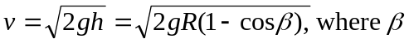is the angle from the vertical at release, and
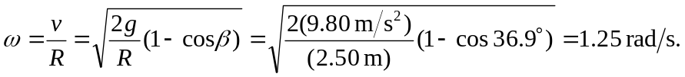
b) will again be 0 when the meatball again passes through the lowest point.
c) 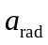 is directed toward the center, and
d) independent of R.

